**Master Functional Document**

|  |  |
| --- | --- |
| **Application** | NGERP - Centra |
| **Service Bundle** |  |
| **Service Request** | NTA Payment |

**Description :**

Role Is A Master Used To Control The User ‘s Access To The NGERP Centra Application.

**Workflow Process :**

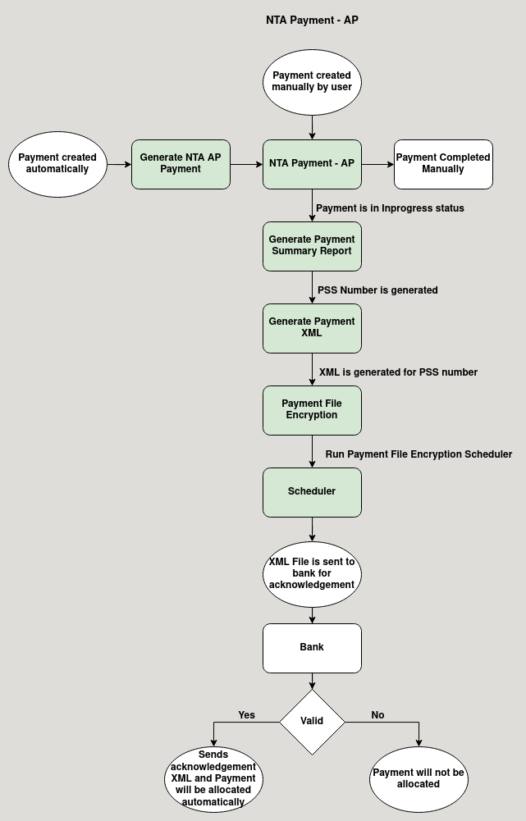

**Business Rules :**

* NTA Payment AP can be created only in HQ.
* NTA Payment can be created manually by the user or can be created using Generate NTA AP Payment

screen.

* There are two ways to complete the NTA Payment AP, manually completing and using Acknowledgement from

Bank.

* Choose the Business partner to whom the payment should be made.
* The business partner should have a Benificary account to complete the payment.
* After this user can manually complet the payment.
* User can also use Acknowledgement to complete the payment
  + First the NTA Payment ocument should be inprogess.
  + Next go to generate Payment Summary Report, Generate PSS number.
  + Go to generate payment XML, generate XML for the PSS number.
  + The XML will be attached in Payment File Encryption for the PSS number.
  + Run the Payment File Encryption to send the XML file to the bank.
  + Then the Bank Validates the XML and Send Acknowledgement.
  + Then the payment will be completed and automatically allocated to NTA AR Invoice.